**User Guide**

**How to Access Book Store Site**

The URL for the Book Store Site is: <http://www.deakin.edu.au/~nlha/online_book_store/>

**To Register**

Simply click on the **register** link on the customer service login page. This will take you to the registration page where you can fill out an online form.

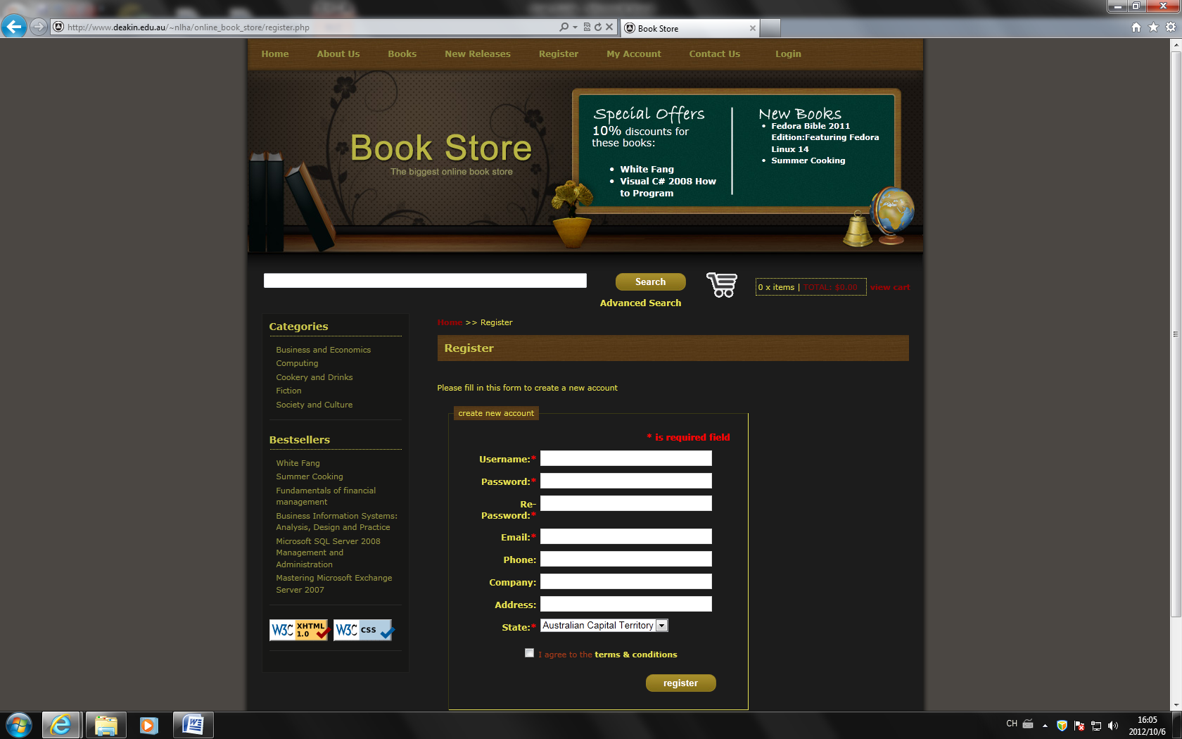

The following registration page will appear. Fill in all the (*) fields, and agree to the *terms&conditions*, then click **register.**

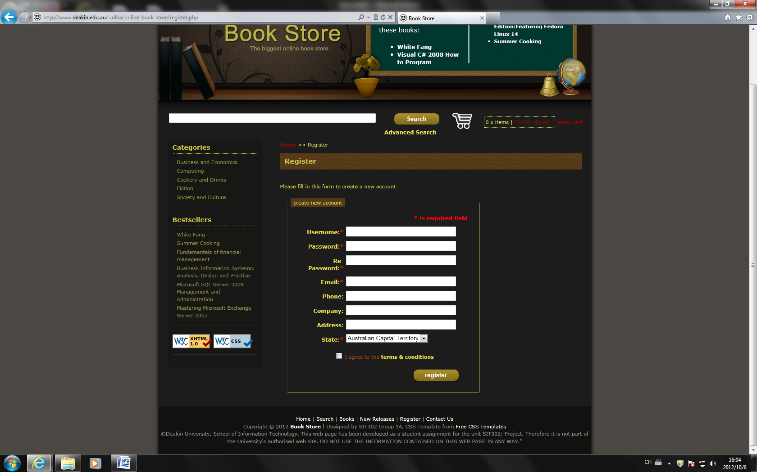

A thank you page will be presented and your information will be sent to the Web Site Administrator.

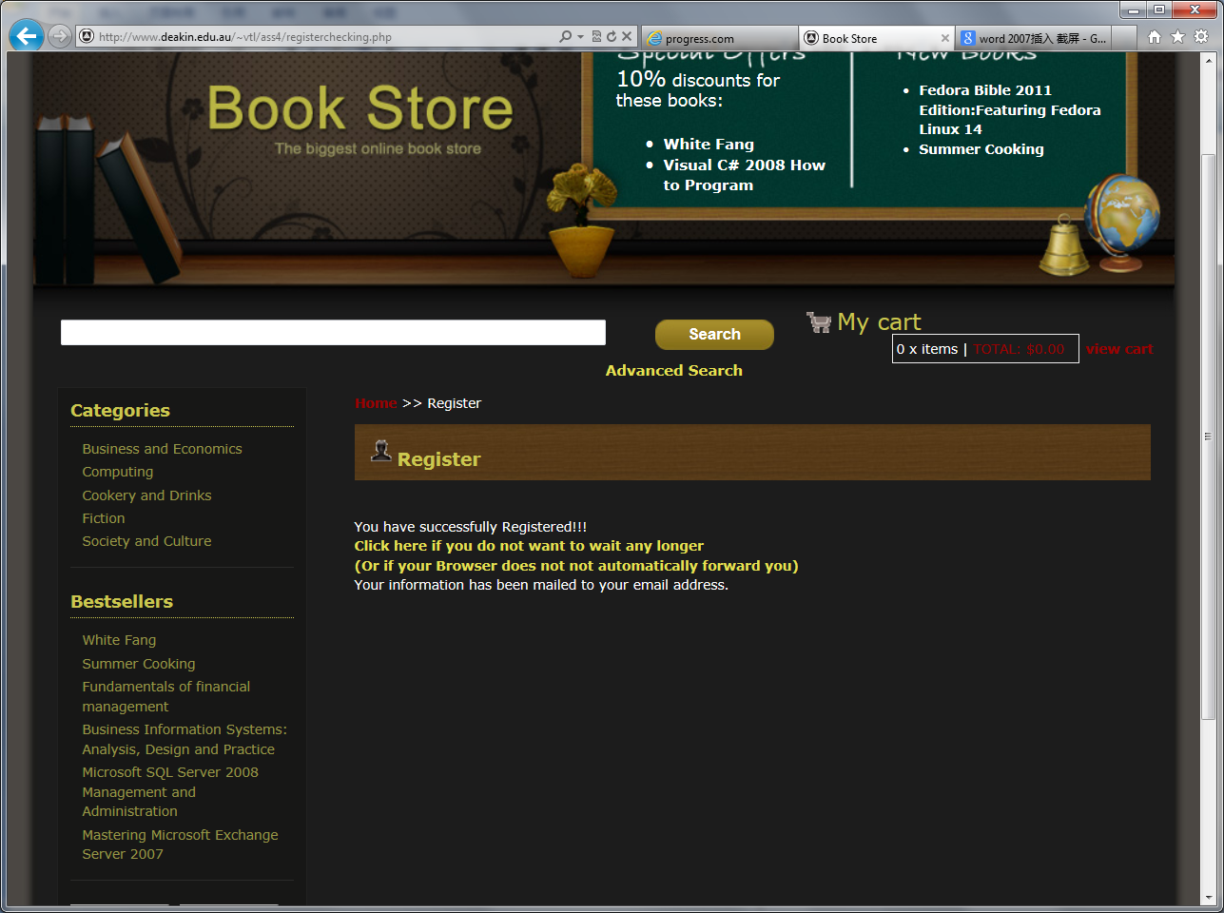

You will then receive an email with your login and password which you will need to login to the site from the Web Site Administrator.

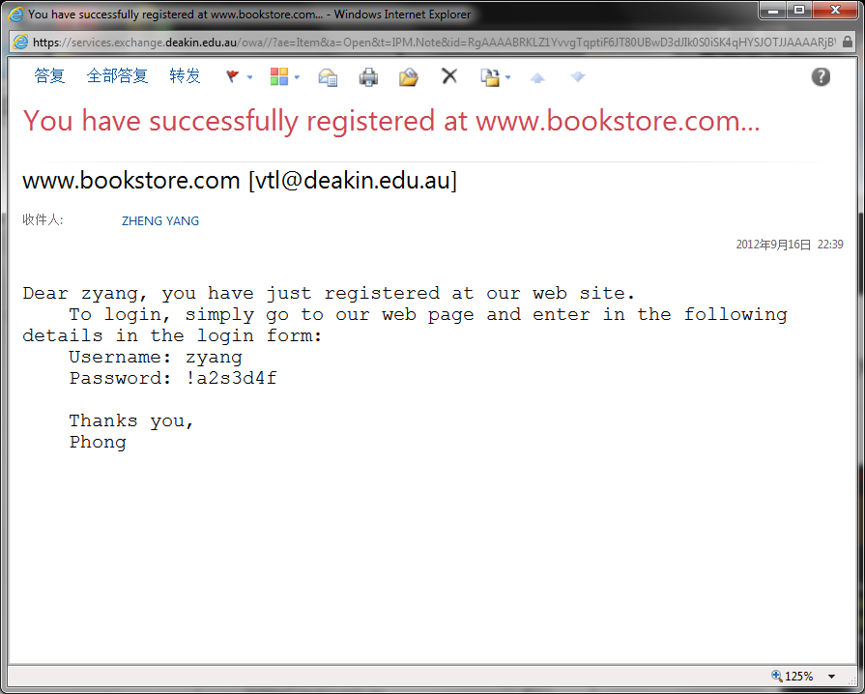

**Logging into the Book Store Web Site**

The URL for the Book Store Login page is: http://www.deakin.edu.au/~nlha/online_book_store/myaccount.php

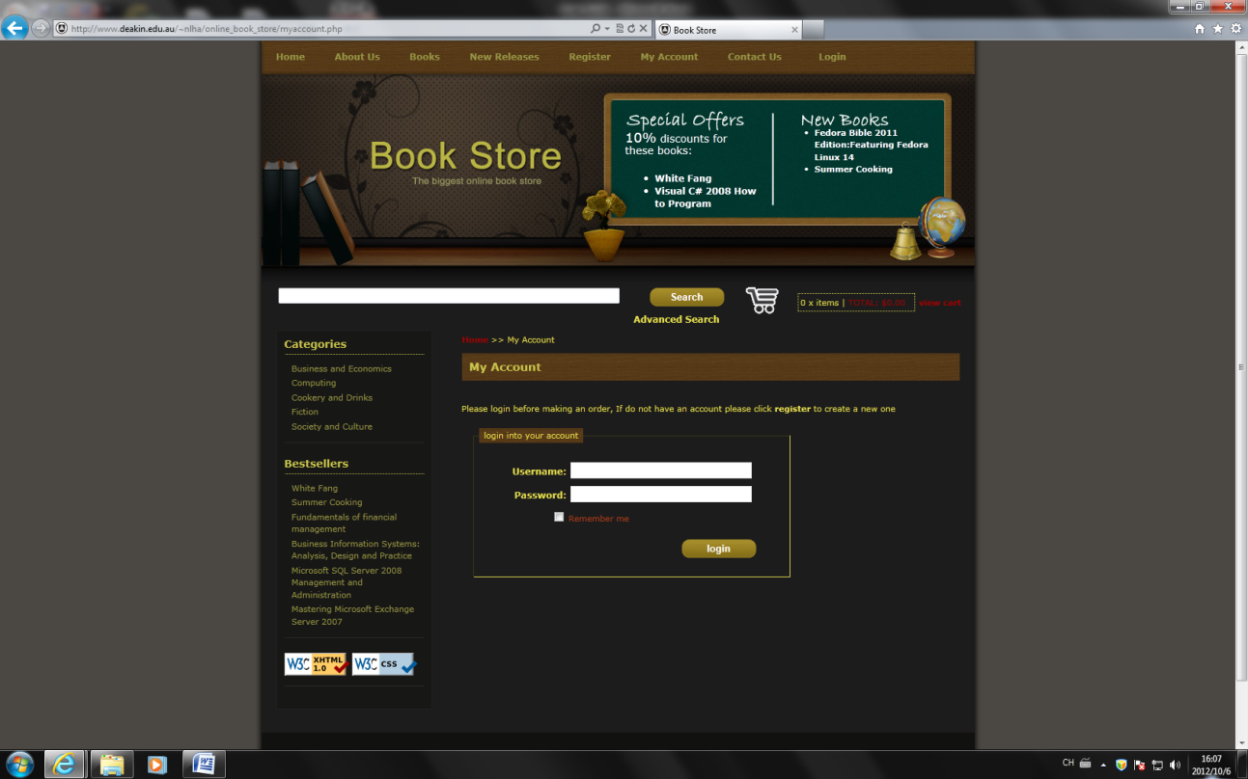

Your ID will be show here.

The Confirmed Page will appear.

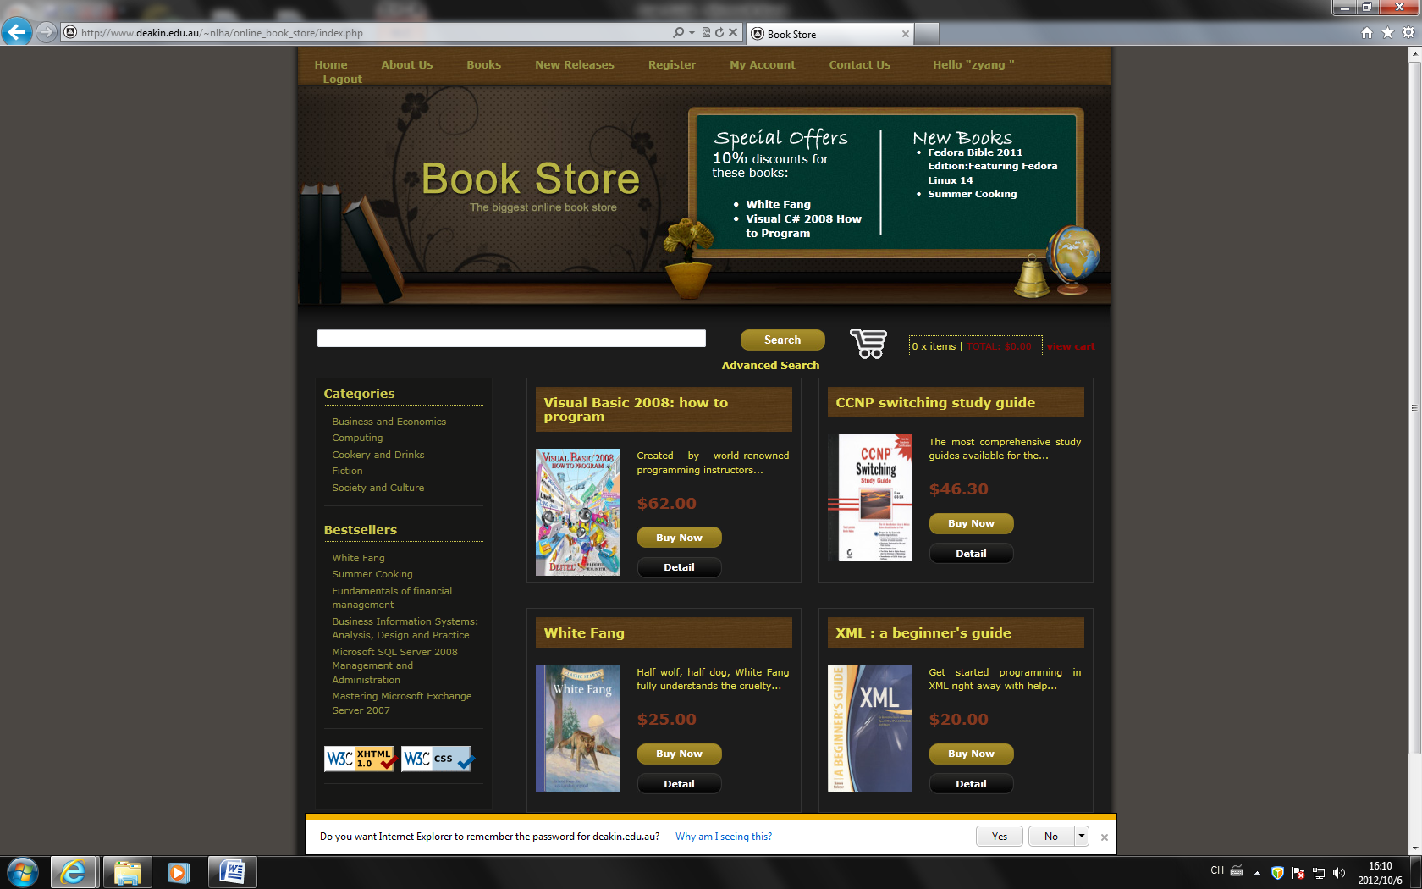

**Update Personal Details**

Click **My Account** in tool bar.



The following Account page will appear. Fill in all the (*) fields, then click **Update.**

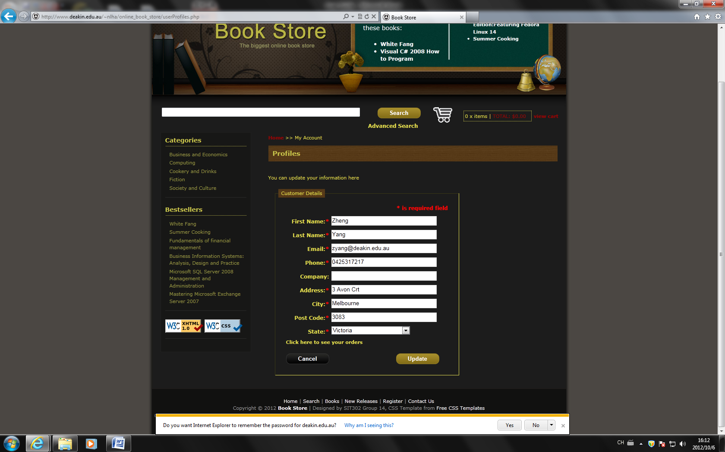

**How to Use Search and Advance Search**

This function will be on each page.



Simply by input some keywords about the books you need. Then click **Search**. The new page contains books you have searched will be appear.

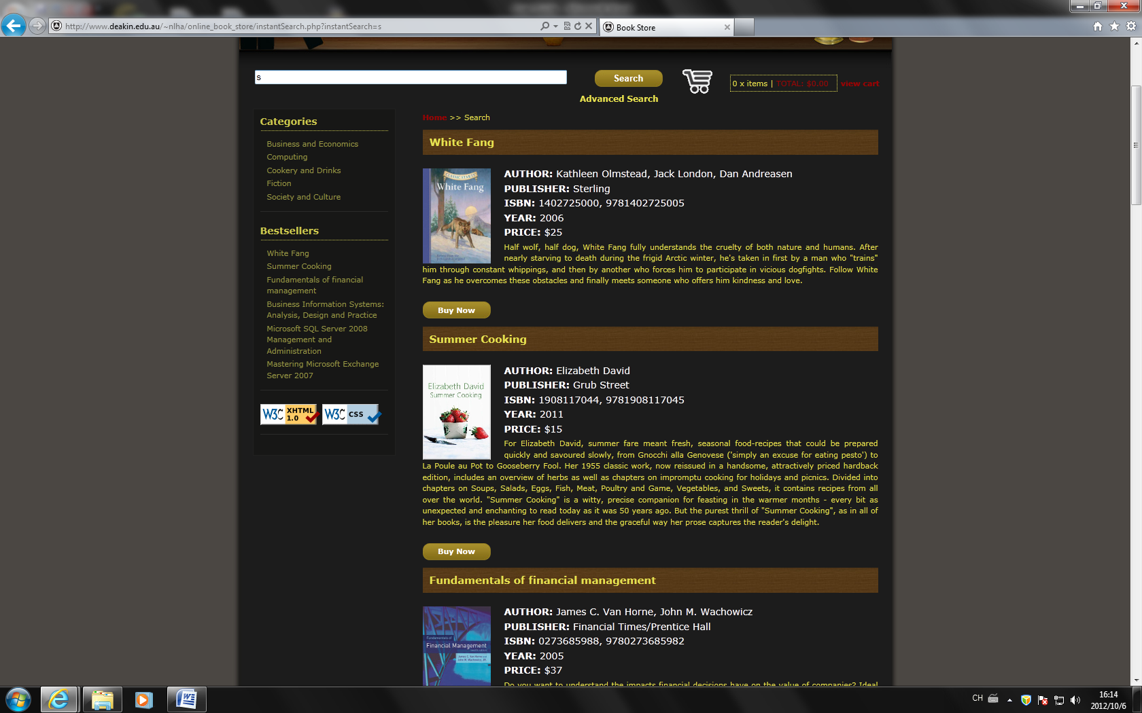

**Advanced Search**

Click **Advanced Search** under the **Search** button. The Advanced Search page will appear. Here you can enter keywords, with advance search by Title, Author and ISBN.

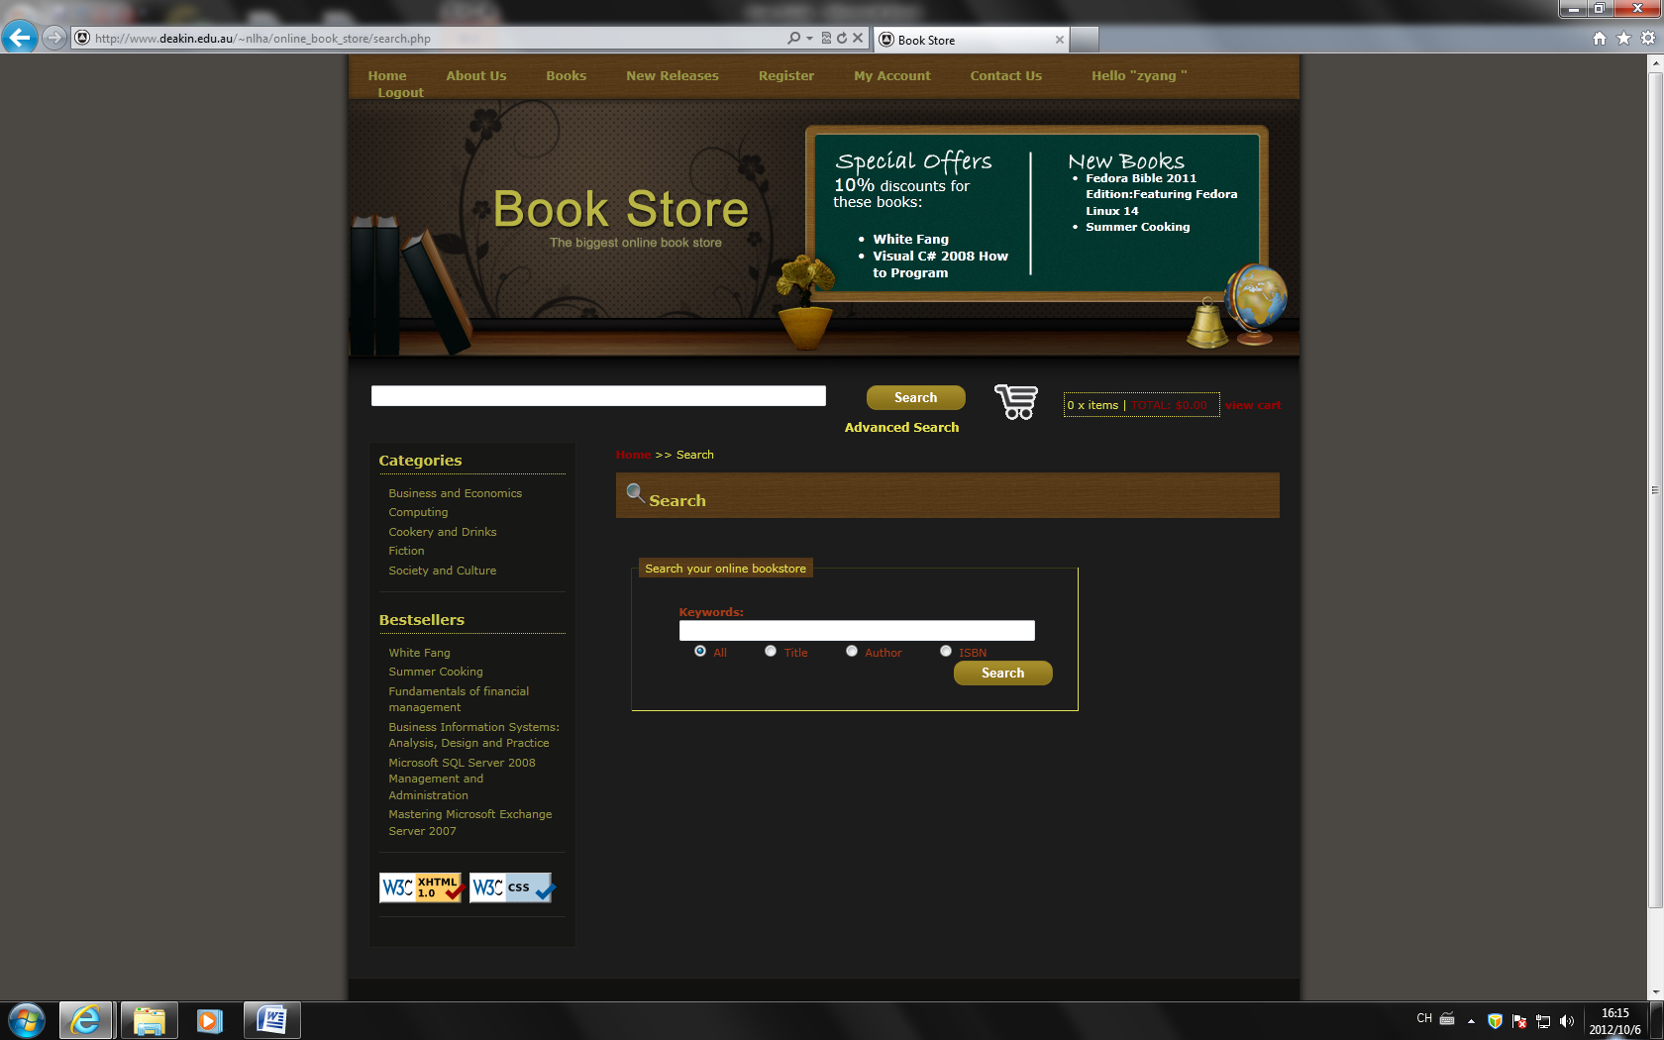

e.g.: Search by ISBN. Input 1402725000 and click ISBN under the text box. Then click **Search**. A following page will appear.

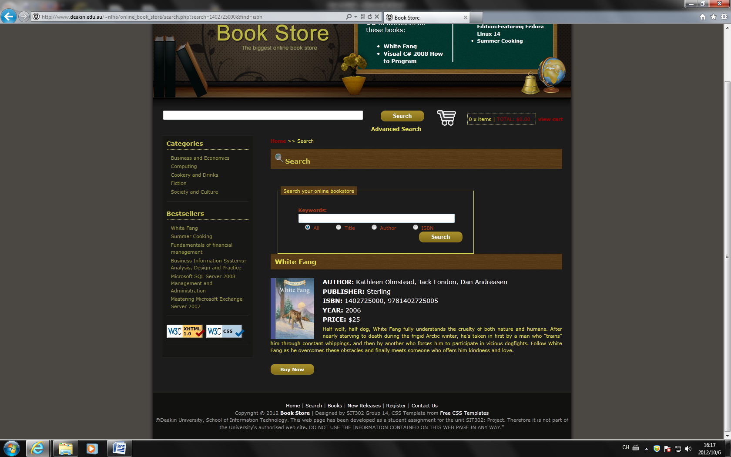

**Shopping Cart**

Once you decide to buy any books. Simply by click **Buy Now** under any books.

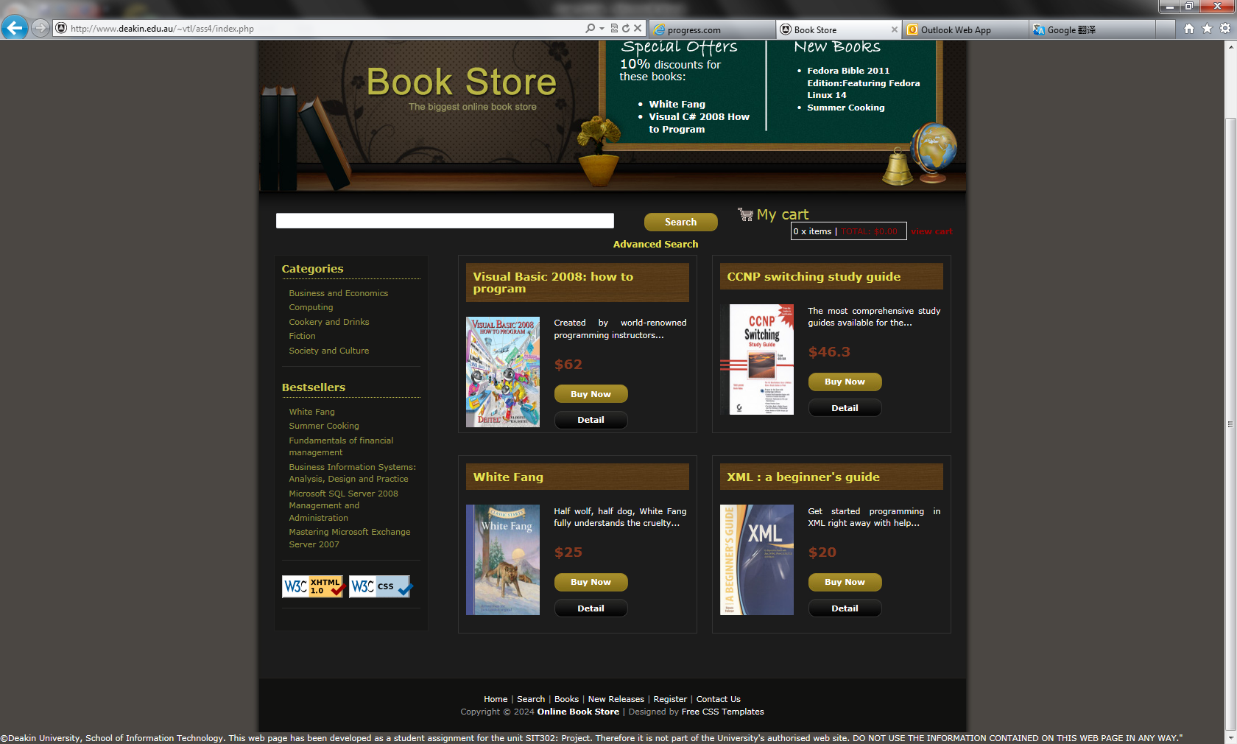

**Cart**

A following page will be presented the book you have select. In this page you can change the quantity of books you need.

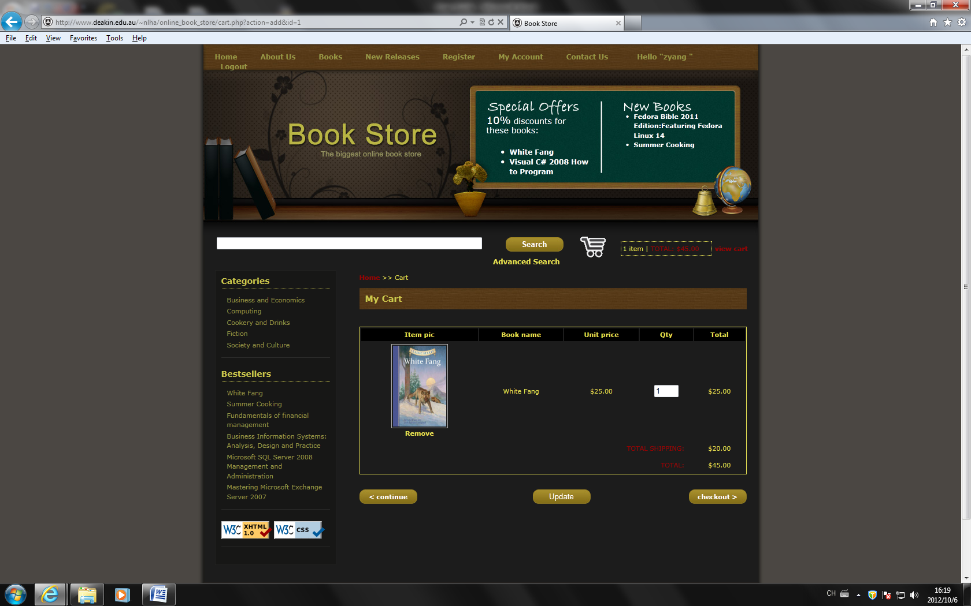

Change quantity here.

**Continue Shopping and Update**

If you want to add more book to the cart. Click **Continue** and then select the book you need. A page with new items will appear. The total cost has been shown at the lower right corner.

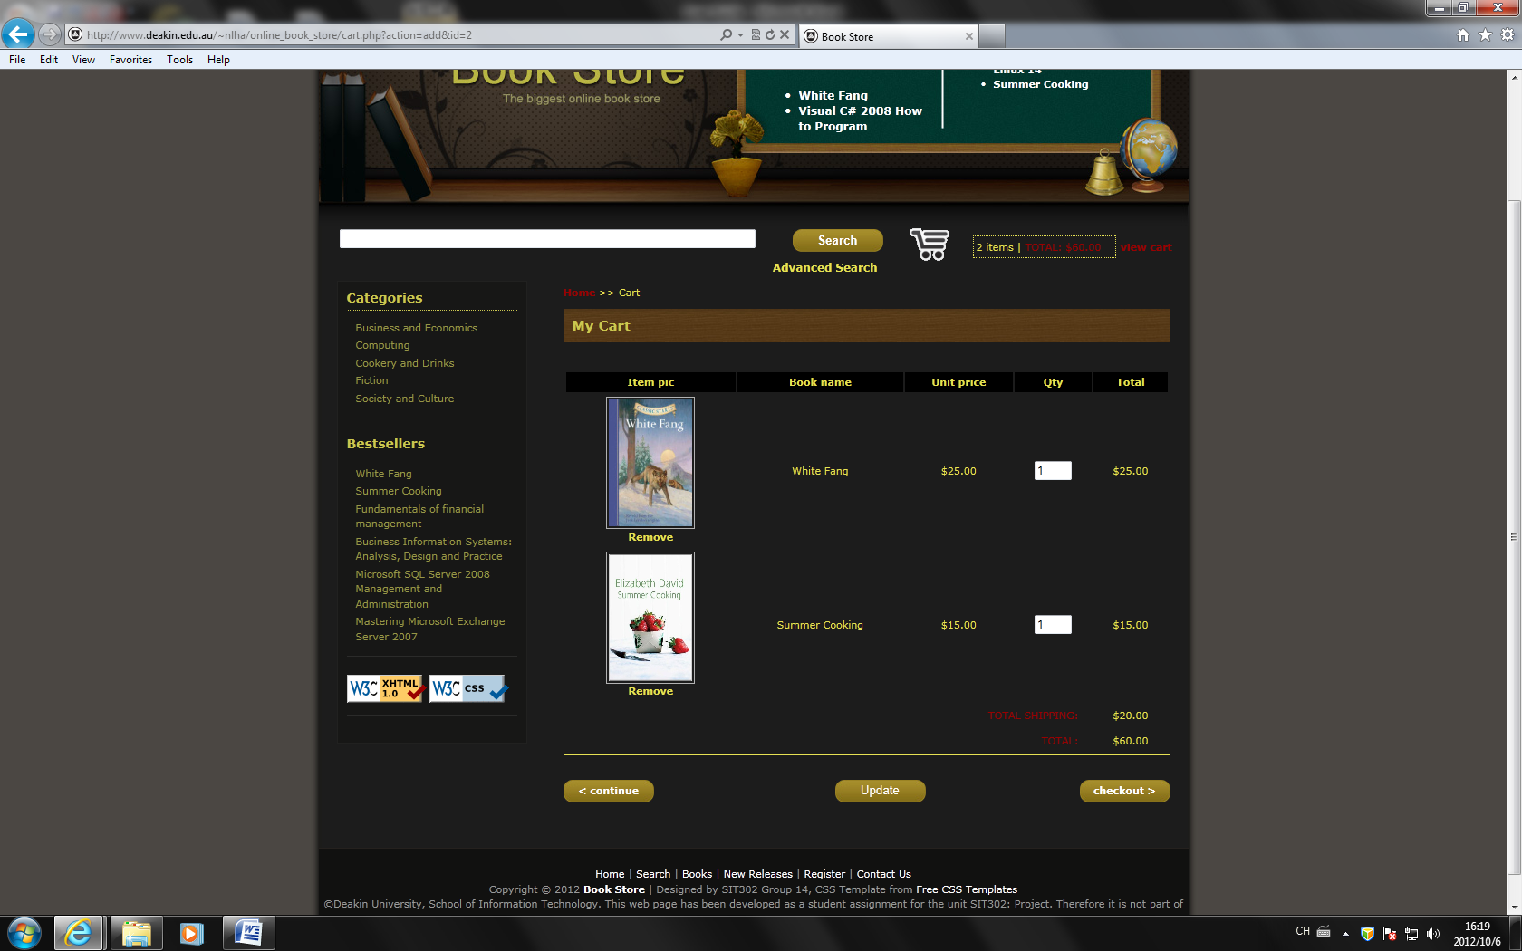

Total cost

**Check Out**

Click **Check Out**. A page with three forms will appear. You have to enter information needed to finish the payment. First by enter the Customer Details, then the Deliver Address and Payment Details.

**Customer Details**

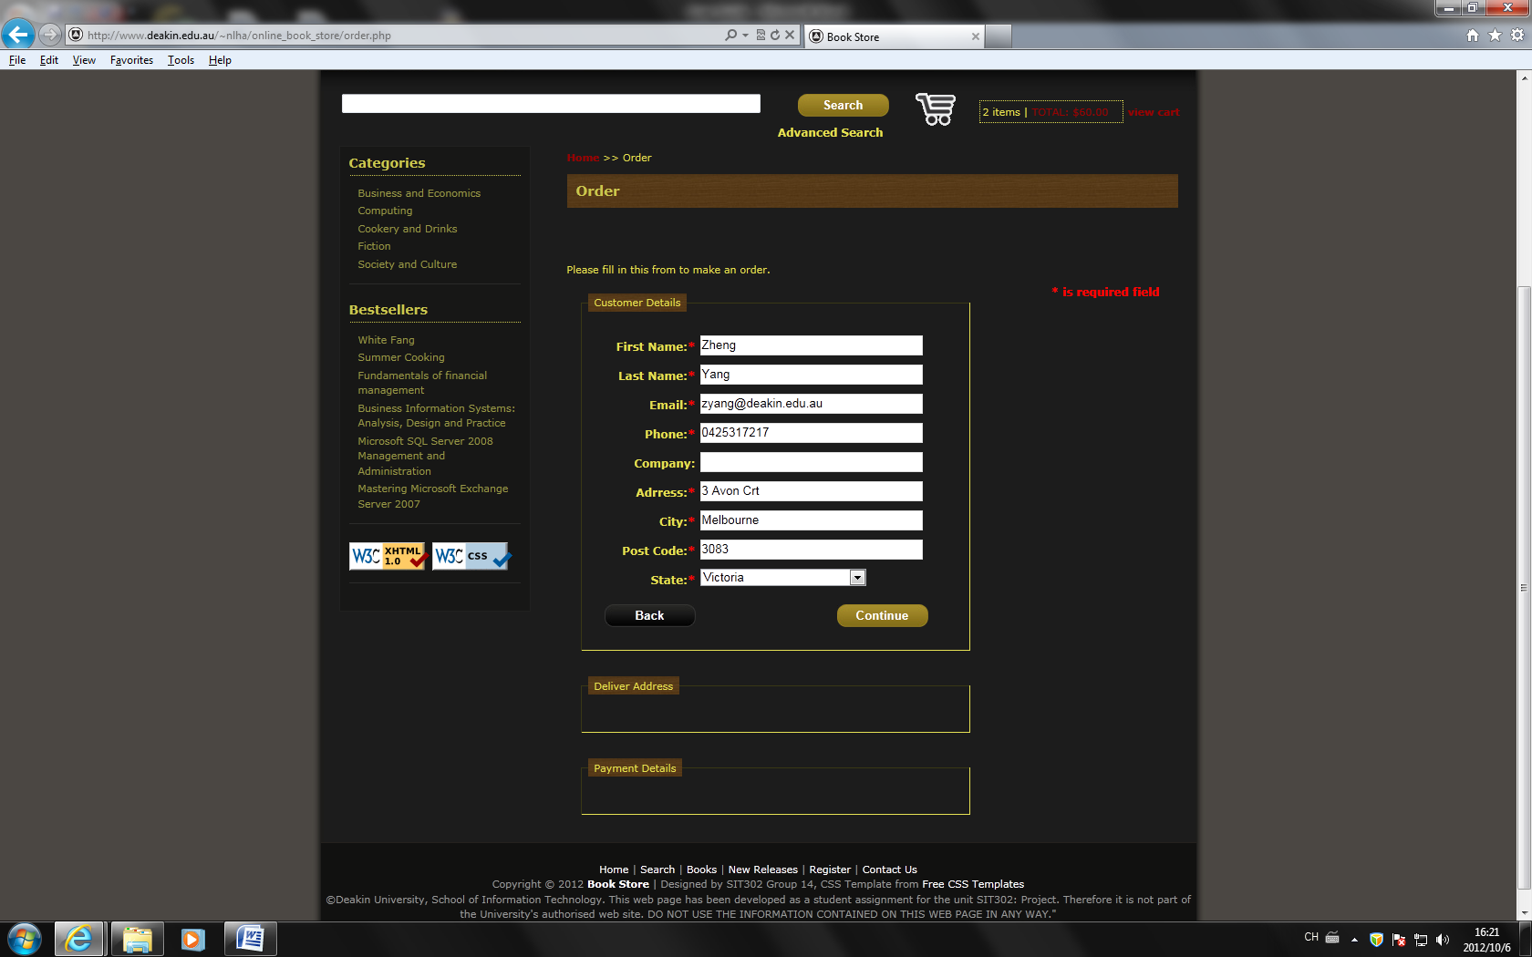

**Deliver Details**

Enter valid address for further delivering.

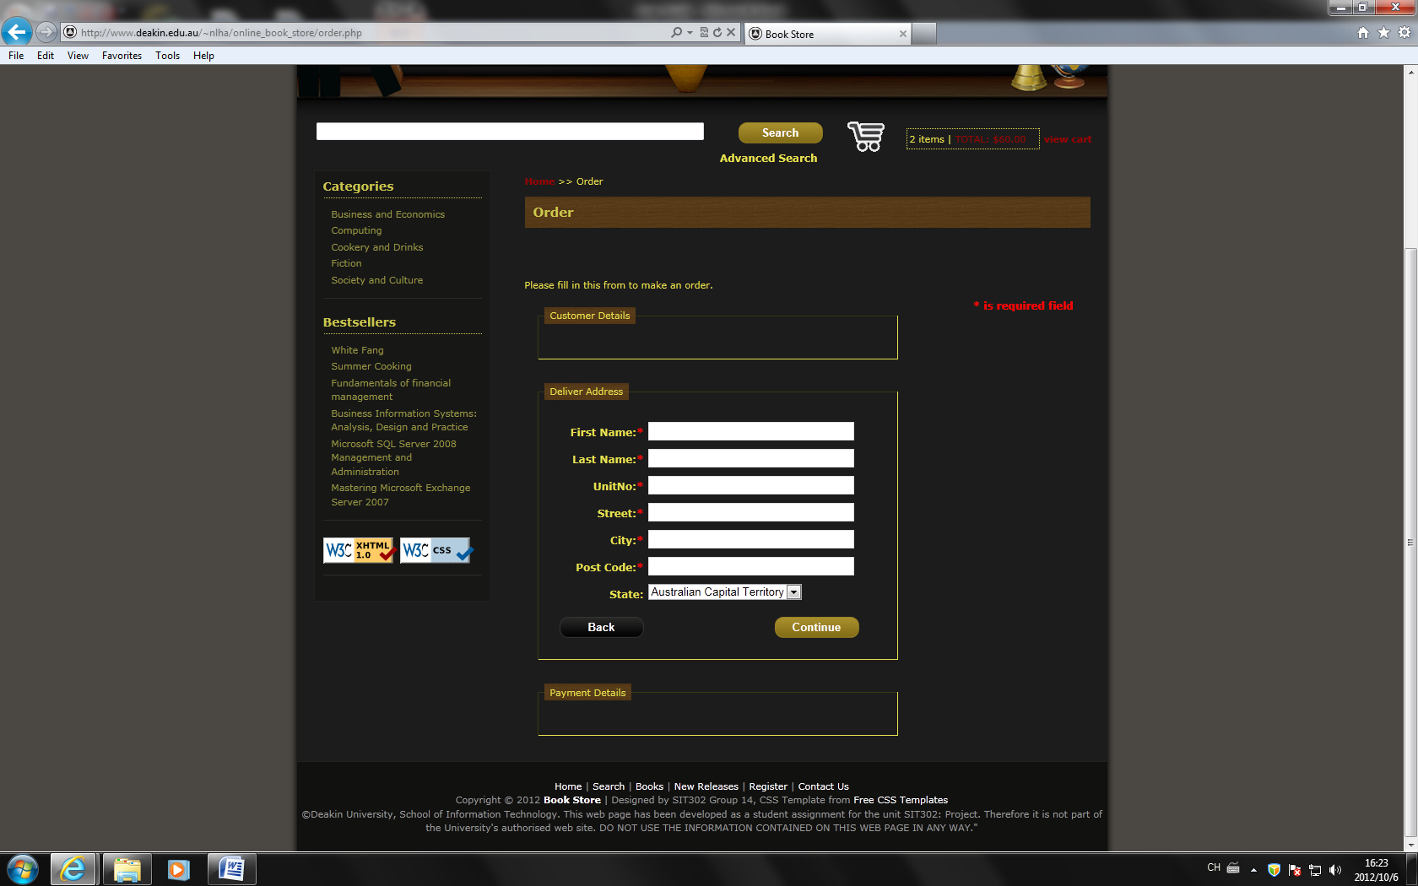

**Payment**

Select one of your favorite method with a drop down list. Then enter the Card Number, Expire Date and CSC Code. Click **Continue** to finish the payment.

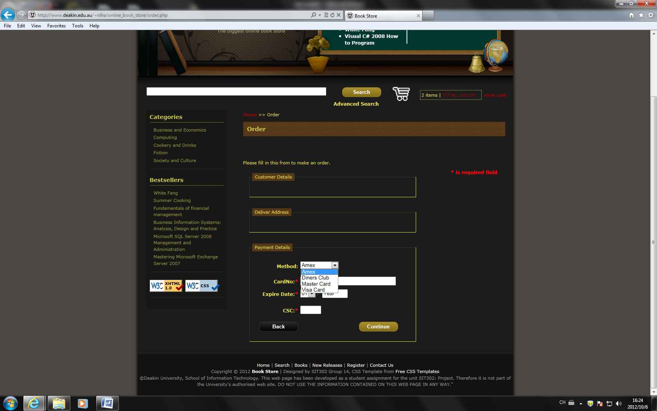

A page will be presented with order list. Congratulation, the payment successes and the Web Site Administrator will soon arrange delivering for you.

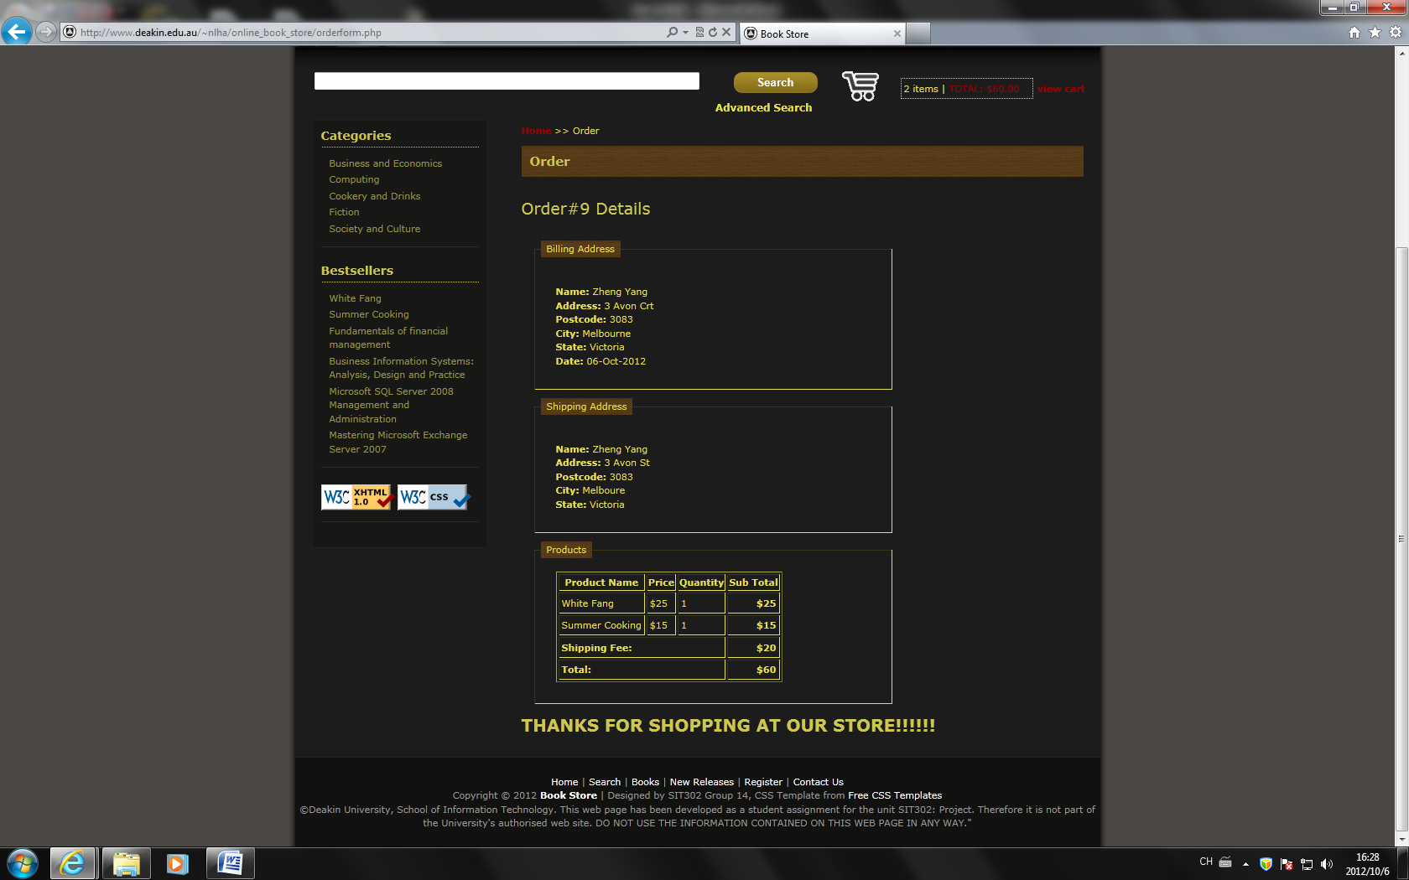

And a confirmed email from web site administrator will send to your mail box.

